LTSA SCITT
Assessment Only Route

Guidance and Eligibility Information
2018 – 2019

Administration team
Emily Wilson – Office Manager
T: 01522 889297
E: ewilson@lincstsa.co.uk
T: Twitter@LTSAScitt
W:www.lincolnshiretsa.co.uk
Address: The Keyworth Centre, Priory City of Lincoln Academy, Skellingthorpe Road, Lincoln LN6 0EP

Eligibility Information

The following information is taken from the Assessment Only Criteria supporting advice, October 2018.

Entry criteria
All AO providers must ensure all of the following prior to acceptance onto the route:

A1.1 GCSE standard equivalent
All providers must ensure, before acceptance onto the route, that:
- all entrants have achieved a standard equivalent to a grade 4 in GCSE English and mathematics
- all those who intend to teach pupils aged 3 to 11 additionally have achieved a standard equivalent to a grade 4 in a GCSE science subject

A1.2 Degree criteria
All providers must ensure, before acceptance onto the route, that:
- all candidates hold a first degree or equivalent qualification granted by a United Kingdom institution or an equivalent degree or other qualification granted by a foreign institution

A1.3 Suitability
All providers must ensure, before acceptance onto the route, that:
- all candidates, as part of the provider’s selection procedures, have taken part in a rigorous selection process designed to assess their:
  - suitability to teach
  - ability to demonstrate meeting all of the Teachers’ Standards without the need for any further training

A1.4 Professional skills test
All providers must ensure, before acceptance onto the route, that:
- all candidates have passed the professional skills tests prior to entry
All providers must ensure, before acceptance onto the route, that:
- all candidates have taught in at least 2 schools

Assessment criteria
All AO providers must ensure all of the following:

A2.1 Provision
All providers must ensure that:
- the content, structure, delivery and assessment of assessment only provision are designed to:
  - enable candidates to demonstrate meeting all of the Teachers’ Standards across the age range of assessment
  - ensure that no candidate is recommended for the award of QTS unless they have demonstrated meeting all of the Teachers’ Standards
b) ensure that no candidate is recommended for the award of QTS unless they have demonstrated meeting all of the standards for QTS.

A2.2 Age ranges
All providers must ensure:
- all candidates recommended for the award of QTS have been assessed as meeting the Teachers’ Standards within one of the following age phases:
  - ages 3 to 11 (primary)
  - ages 7 to 14 (middle)
  - ages 11 to 19 (secondary)
Assessment must ensure that candidates have the knowledge and skills they need to be able to teach in one of the specified age phases. Typically, assessment will take place across the following age ranges:
- 3 to 7, 5 to 11, or 7 to 11 for primary assessment
- 7 to 14 for middle assessment
- 11 to 16 or 14 to 19 for secondary assessment

A2.3 Candidate assessment
All providers must ensure that:
- the process of assessment:
  - includes the assessment of practical teaching in a school (or early years or further education setting)
  - typically does not last longer than 3 months
AOR Fees
Our AOR fees are:
- For LTSA Non-Alliance members – £2,100 per candidate*
- For LTSA Alliance member – £1,785 per candidate*

Please refer to the AOR Partnership Agreement for full details of our finance.

*Please note additional costs may also incur should an application be unsuccessful or for expenses. Contact us for further information.

Self-funding: Should a candidate wish to fund AOR themselves, the fees remain the same as the school they are employed with. Self-funded candidates who are employed with an LTSA Alliance school will pay the same rate as Alliance member fees, those outside of LTSA Alliance will pay the Non-Alliance fee rate.
Frequently Asked Questions

What if I do not have a degree in my specialist subject (Secondary)?
If your degree is not within you specialist teaching subject area we are still interested in hearing from you. If you have a good A Level in your specialist subject this is very helpful. We can also consider your KS4 teaching experience, particularly when delivered to high ability groups, accessing subject challenge.
Please contact us for further information.
Guidance from DfE states that:
For those being assessed in non-specialist primary settings, the assessment process must cover the relevant curriculum subjects. For secondary candidates, providers will need to assess the necessary knowledge and understanding of their subjects and related pedagogy. Candidates that are assessed in a subject that is always or predominantly taught in only one age range (for example post 16) may need to demonstrate subject knowledge in a related subject if they do not have the opportunity to be assessed in their subject across the full age range.

What if I have only taught in school one setting?
You must have second school teaching experience before you can apply. Contact us with any specific queries. Guidance from DfE states that:
Candidates must have taught in 2 schools, early years or further education settings before entry to the assessment only route. It is not sufficient for candidates only to have had experience of 2 schools or settings. Providers should consider whether a candidate’s prior experience of teaching in schools provides enough evidence to allow the provider to confidently count those previous teaching experiences towards the 2 schools required.
Providers will need to be clear about the nature and extent of the prior experience, whether it offered the candidate the opportunity to teach children and young people and whether, taken together with other experiences, it prepared the candidate sufficiently to meet the Teachers’ Standards.
Typically, a candidate with fewer than 2 years of teaching experience in schools as an unqualified teacher would be unsuitable for the assessment only route. Practical teaching experience for the purposes of assessment only is not restricted to taking place wholly or mainly in England

What if I have one year’s experience (or equivalent) of teaching? (Primary and Secondary)
Contact us. We will look at the teaching experience you currently have and work with your school to put together an action plan to secure the required experience moving forward.

Which subjects do you offer AOR? (Secondary)
We work with candidates in any secondary subject.

Are candidates who have QTLS status eligible for the AO route?
Yes.
Although QTLS status holders can now work in schools as qualified teachers, without needing to hold QTS, they must maintain their QTLS status and membership with the Institute for Learning (IfL) to do so.
Some QTLS status holders may still wish to follow the AO route, but providers should be confident this is the result of an informed decision.
This link might be useful:
https://set.et-foundation.co.uk/professionalism/gaining-qtls/qtls-faqs/#qtlsqts

LTSA SCITT – Guide to AOR Application Processes

The school makes an enquiry on behalf of a candidate through the administration team.

The adminstration team send the AOR information pack to the school and the candidate. This includes the AOR application form, Health Questionnaire, DfE Data Tracking form and the AOR Guidance and Eligibility Information.

School and candidate to check against the eligibility information to ensure that the candidate has the relevant experience and qualifications to apply for AOR. Queries in relation to this to be directed towards the administration team.
If the candidate does not have teaching experience in a second setting this will need to be organised. For candidates who have not taught in a second school, a minimum 6 weeks’ block placement should be organised by their school/the candidate. Ensure all relevant age and ability ranges are covered.

The application forms should be completed and sent to the administration team.
NB The school must send the completed application form through (Part A and B)

If it appears that all the criteria for AOR are met, the candidate will be emailed an ‘eligible to apply letter’. At this point, if the candidate has not already done so, they should register for the professional skills tests. This booking is completed on line. It is advised that candidates practice the tests before attempting them.

Once the candidate has passed both skills tests, the candidate should contact LTSA SCITT Administration to confirm.

Once the full application has been processed, the Initial AOR Assessment Visit can be booked. The school must also sign the LTSA AOR Partnership Agreement at this point.

Initial AOR Assessment Visit - An LTSA Programme leader to visit the school. AOR Criteria details the following:
A2.2 All candidates recommended for the award have been assessed as meeting the standards for QTS within one of the following age phases:
Ages 3-11 (primary) Ages 7-14 (middle) Ages 11-19 (secondary)
Assessment must ensure that candidates have the knowledge and skills they need to be able to teach in one of the specified age phases. Typically, primary assessment will take place across the 3-7, 5-11, or 7-11 age ranges. For middle, assessment typically will take place across the 7-14 age range, and for secondary, assessment will typically take place across the 11-16 or 14-19 age ranges.
The Initial Assessment visit will include the following elements
- Two lesson observations will take place as part of this visit. Ensure the lessons demonstrate teaching to cover the above criteria. These lessons are to be jointly observed with a member of the school leadership team (for Secondary applicants a senior member of the faculty team should observe the KS4 lesson to help quality assure subject specific knowledge).
- A 30-minute interview will also take place involving the LTSA Programme leader and at least one senior leader from the school as part of the panel.
- Paperwork will also be collated and photocopied – original copies must be seen. This includes: Degree certificate, evidence of standard qualification equivalent to GCSE Grade 4 in Maths and English (Science to be included for those being assessed within Age Phase 3-11), proof of any name changes where applicable, Photographic ID, NARIC documents where applicable. DBS certificates/numbers do not need to be seen – it is the responsibility of the school to ensure this is in place. Check again that the National Skills test in Literacy and Numeracy have both been passed.
- Presentation of the portfolio of evidence by the candidate to the assessor.
- A briefing about the format of the final assessment.

On successful completion of the Initial AOR Assessment Visit, the candidate will be registered on the AO route. There is a maximum period of three months before which the school-based Final Assessment must be completed. The school and candidate will receive copies of both lesson observation feedback forms and the AOR Initial assessment form.

When the candidate is ready, the Final Assessment process will begin. Two further lesson observations will take place. The Programme Leader will also assess progress against the portfolio of evidence. A final assessment report will be written by the LTSA Programme Leader.

LTSA will send copies of lesson feedback to the candidate and the school.
LTSA should have all evidence in place to recommend the candidate to DfE for award of QTS.

School to receive the invoice from LTSA

Once the invoice has been paid the school and the candidate will receive a copy of the final assessment form.
The Teachers’ Standards
There are 8 Teachers’ Standards which need to be demonstrated and evidenced by the end of the programme. They are presented in three parts:
1. The Preamble summarises the values and behaviour that all teachers must demonstrate throughout their careers
2. Part 1 comprises the 8 Standards for Teaching;
3. Part 2 comprises the standards for Professional and Personal Conduct

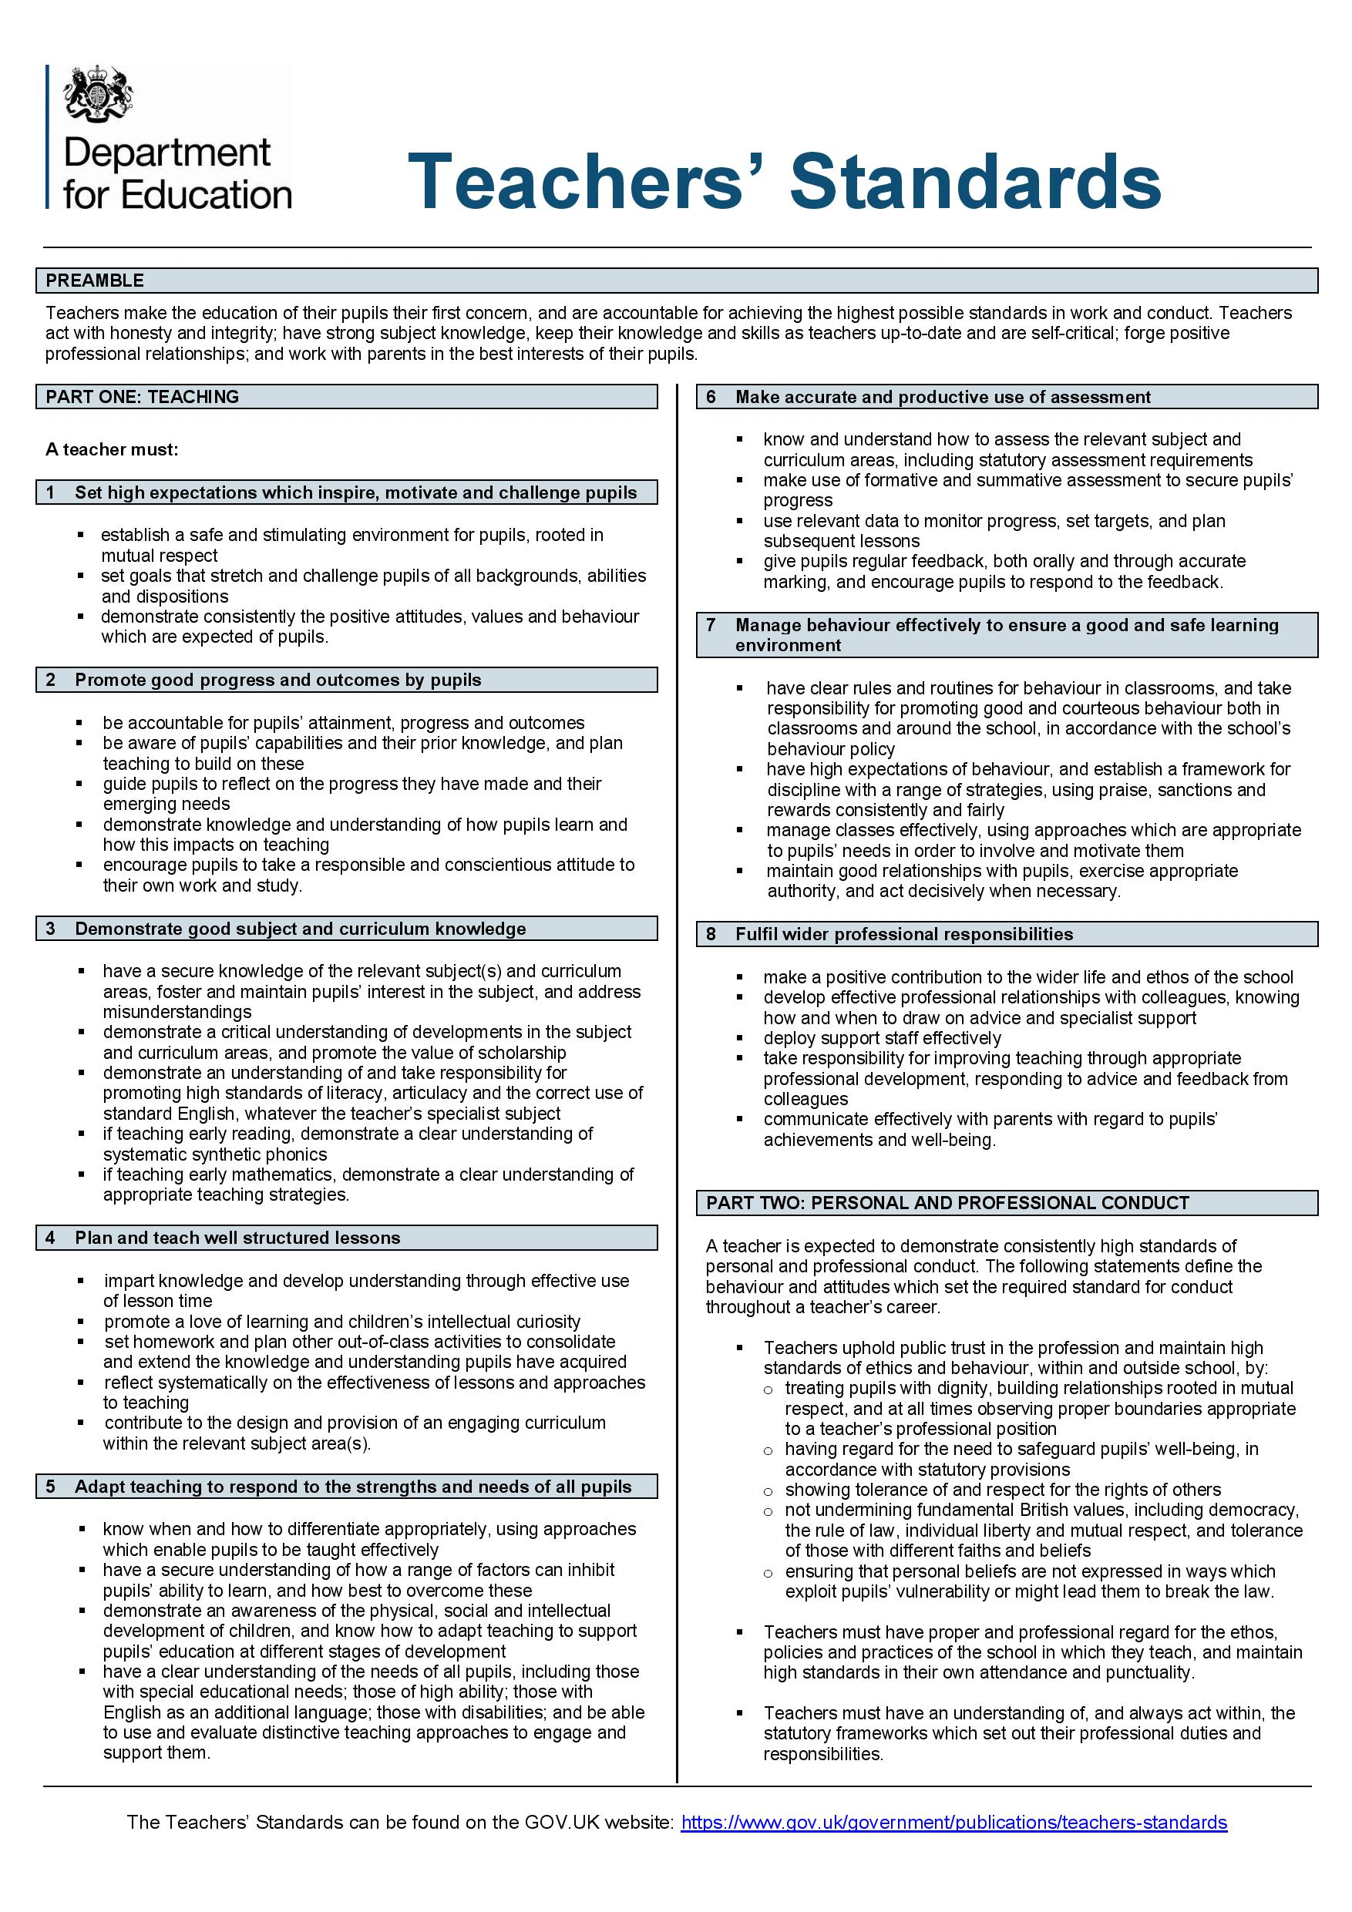

Evidence of Demonstrating the Teachers’ Standards

The evidence portfolio can be either paper or electronic. It should be arranged according to the Teachers’ Standards, to present the evidence relevant to each individual standard.

‘Part 2’ of the Teachers’ Standards can be evidenced by testimonials from the school and certificates where appropriate.

Where a piece of evidence meets more than one Standard, cross reference it, highlighting the relevant section for the Standard being claimed. However, you should not use one piece of evidence too often, as a range of evidence sources need to be considered.

It is vital that the evidence provided indicates that the candidate has met all the Teachers’ Standards. It is also important to consider how teaching in the second school has contributed towards meeting the Teachers’ Standards.

The evidence portfolio is required at the time of the Initial Selection + Assessment Visit. The assessor will indicate where supplementary evidence might be required in preparation for the Final Assessment Visit. Whilst it is not a requirement that the portfolio will be fully completed by the date of the Initial Selection + Assessment Visit it must be well under way.

You will need to ensure you include a range of evidence types to demonstrate how you have met all Teachers’ Standards. Evidence could include:

Examples of lesson planning

A range of lesson observations and evaluations by experienced teachers

Candidate reflections and evaluations of their taught lessons

Examples of marked work and target setting linked to assessment criteria

Annotated Scheme of Learning Include planning for groups of learners within the class

Annotated seating plans showing the candidates reasoning for these

Examples of teaching strategies trialled with evaluation of their impact

Evidence of examples of behaviour for learning strategies utilised

Examples of resources selected and designed – with annotations and evaluations

Annotated policies and evidence of how these have been followed

Evidence of how questioning skills have been developed and utilised

Examples of tracking sheets including annotations to show how data has been analysed

Details of interventions set in response to data analysis including analysis of impact/evaluative commentary

Reflection and wider reading based around the role of assessment for and of learning

Evidence of participation in APP, moderation activities or joint assessment

Notes to show how prior CPD has been used to enhance teaching practice

Demonstrate of the awareness of how you can take account of diversity / avoid and cultural stereotyping/ reinforce positive messages about minority ethnic groups and cultures in your subject/phase area

Planning for and promotion of high standards of ICT /Literacy / Numeracy skills to support pupils’ learning

Planning to demonstrate homework provision and how this is used to extend and consolidate learning

Examples of marked pieces of homework

Demonstrate how you plan for differentiation/ personalisation.

Evidence to show that you are aware of the discrete groups you teach (Pupil premium, Free school meals, girls/boys. EAL, Looked after Children etc)

Evidence of any out of school activities that you have been involved in – through planning and staffing.

Engagement in extracurricular/out of school learning activities

Lesson observation report with a focus on TA deployment/TA witness statements etc

Evidence of report writing

Evidence of communicating and engaging with parents and the impact this has made.

Evidence on your pastoral responsibilities

Evidence of Safeguarding training and a witness statement to demonstrate how you follow policy

